

oneM2M
Technical Report
Document Number | TR-0030-V-0.3.0
Document Name: | Service Layer Forwarding
Date: | 2018-Jan-08
Abstract: | This technical report investigates and defines a service layer forwarding capability that allows oneM2M requests and responses to be forwarded across multiple CSE hops which is currently lacking in the Release 1 and 2 architecture.
Template Version:23 February 2015 (Dot not modify)

This Specification is provided for future development work within oneM2M only. The Partners accept no liability for any use of this Specification.
The present document has not been subject to any approval process by the oneM2M Partners Type 1. Published oneM2M specifications and reports for implementation should be obtained via the oneM2M Partners' Publications Offices.

About oneM2M
The purpose and goal of oneM2M is to develop technical specifications which address the need for a common M2M Service Layer that can be readily embedded within various hardware and software, and relied upon to connect the myriad of devices in the field with M2M application servers worldwide.
More information about oneM2M may be found at: http//www.oneM2M.org
Copyright Notification
© 2016, oneM2M Partners Type 1 (ARIB, ATIS, CCSA, ETSI, TIA, TSDSI, TTA, TTC).
All rights reserved.
The copyright and the foregoing restriction extend to reproduction in all media.

Notice of Disclaimer & Limitation of Liability
The information provided in this document is directed solely to professionals who have the appropriate degree of experience to understand and interpret its contents in accordance with generally accepted engineering or other professional standards and applicable regulations. No recommendation as to products or vendors is made or should be implied.
NO REPRESENTATION OR WARRANTY IS MADE THAT THE INFORMATION IS TECHNICALLY ACCURATE OR SUFFICIENT OR CONFORMS TO ANY STATUTE, GOVERNMENTAL RULE OR REGULATION, AND FURTHER, NO REPRESENTATION OR WARRANTY IS MADE OF MERCHANTABILITY OR FITNESS FOR ANY PARTICULAR PURPOSE OR AGAINST INFRINGEMENT OF INTELLECTUAL PROPERTY RIGHTS. NO oneM2M PARTNER TYPE 1 SHALL BE LIABLE, BEYOND THE AMOUNT OF ANY SUM RECEIVED IN PAYMENT BY THAT PARTNER FOR THIS DOCUMENT, WITH RESPECT TO ANY CLAIM, AND IN NO EVENT SHALL oneM2M BE LIABLE FOR LOST PROFITS OR OTHER INCIDENTAL OR CONSEQUENTIAL DAMAGES. oneM2M EXPRESSLY ADVISES ANY AND ALL USE OF OR RELIANCE UPON THIS INFORMATION PROVIDED IN THIS DOCUMENT IS AT THE RISK OF THE USER.

Contents
Contents 3
1 Scope 4
2 References 4
2.1 Normative references 4
2.2 Informative references 4
3 Definitions, symbols and abbreviations 4
3.1 Definitions 4
4 Conventions, 4
5 Analysis of Existing oneM2M Forwarding Mechanisms 5
5.1 Registration 5
5.2 Addressing and Forwarding 6
5.3 Limitations 7
6 Potential solutions 8
6.1 Forwarding using descendant CSE information 8
6.1.1 Description 8
6.1.2 New Attribute of <remoteCSE> 8
6.1.2 New Service Layer Forwarding Procedures 10
6.1.2.1 Procedure for a CSE to forward a Message 10
6.1.2.2 Registration procedure support for service layer forwarding 10
6.1.2.2.1 Procedure for <remoteCSE> create 10
6.1.2.2.2 Procedure for <remoteCSE> update 10
6.1.2.2.3 Procedure for <remoteCSE> delete 11
7 Conclusions 11
History 11

1 Scope
The present document studies and analyzes existing oneM2M service layer message forwarding functionality and its shortcomings. The document also studies and analyzes potential ways to address these shortcomings.

2 References
References are either specific (identified by date of publication and/or edition number or version number) or non-specific. For specific references,only the cited version applies. For non-specific references, the latest version of the referenced document (including any amendments) applies.

2.1 Normative references
The following referenced documents are necessary for the application of the present document.
Not applicable.

2.2 Informative references
The following referenced documents are not necessary for the application of the present document but they assist the user with regard to a particular subject area.
[i.1] oneM2M Drafting Rules (http://www.onem2m.org/images/files/oneM2M-Drafting-Rules.pdf)

3 Definitions, symbols and abbreviations

3.1 Definitions
For the purposes of the present document, the [following] terms and definitions [given in ... and the following] apply:
service layer forwarding: routing of requests from one CSE to another based upon the CSE-ID information specified in the request message

4 Conventions,
The key words “Shall”, ”Shall not”, “May”, ”Need not”, “Should”, ”Should not” in this document are to be interpreted as described in the oneM2M Drafting Rules [i.1]

5 Analysis of Existing oneM2M Forwarding Mechanisms

5.1 Registration
A CSE performing registration to another CSE is referred to as a Registree CSE. The CSE to which a CSE is registering to is referred to as the Registrar CSE. The Registration procedure requires the creation of two resources (a <remoteCSE> on the Registrar CSE and a <remoteCSE> on the Registree CSE. The following is the CSE registration procedure as described in TS-0001 section 10.1.1.2.1. In this procedure, the Originator is the Registree CSE and the receiver is the Registrar CSE.
It is worth noting, that during the oneM2M CSE registration procedure, a Registree CSE does NOT share any information with its Registrar CSE regarding whether or not it has other CSEs registered to it. As a result, a Registrar CSE does not have any awareness of CSEs that may be registered to any of its Registree CSEs.
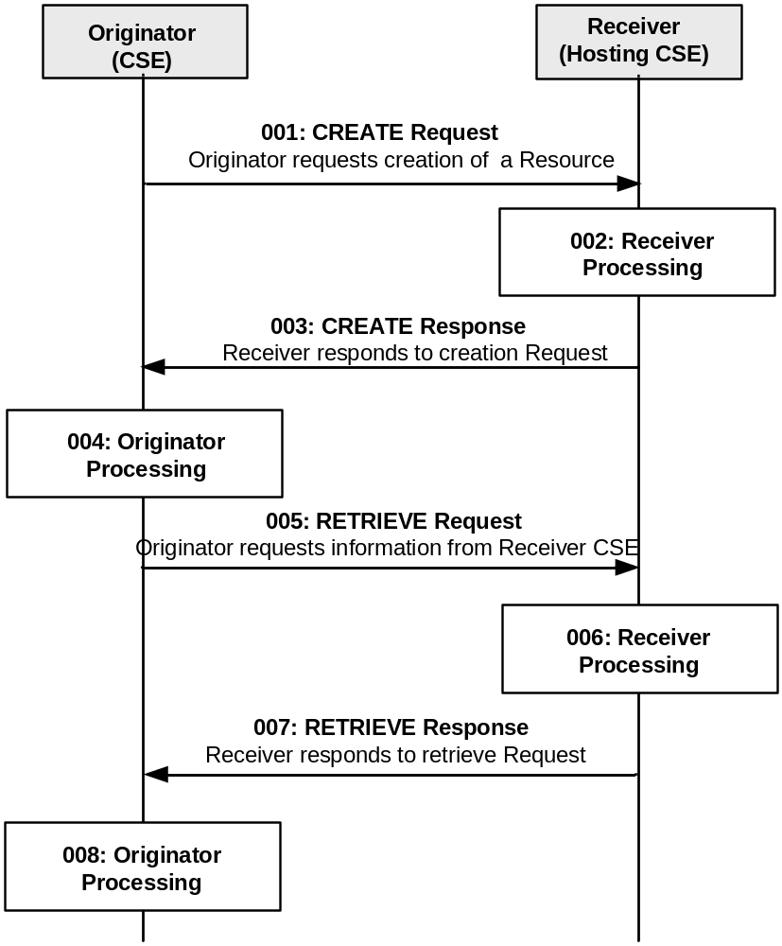
Figure 5.1-1 Procedure for Creating a <remoteCSE> Resource
Step 001: The Originator shall send the CREATE Request message.
Step 002: The Receiver shall process the registration request message.
Step 003: The Receiver shall respond with a registration Response message that contains the address/URI of the registered CSE.
Step 004: The Originator, upon receipt of the CREATE response message, shall create a <remoteCSE> resource locally under its <CSEBase> resource. This resource is representing the Receiver CSE. The Originator shall provide the appropriate values to all mandatory parameters.
Step 005: The Originator may issue a RETRIEVE Request towards the Receiver (same To as for the CREATE request message) to obtain the optional parameters of the <remoteCSE> resource created at the Receiver as for step 004 (e.g. labels, accessControlPolicyIDs attributes).
Step 006: The Receiver verifies that the Originator has the appropriate privileges to access the information.
Step 007: The Receiver sends a RETRIEVE response message.
Step 008: The Originator shall update the created <remoteCSE> resource for the Receiver with the information obtained in step 007.

5.2 Addressing and Forwarding
Within the oneM2M architecture, service layer forwarding is based upon routing of requests from one CSE to another based upon the CSE-ID information specified in the request message. For a oneM2M request to be forwarded from one CSE to another CSE, the “To” parameter of the request must include a CSE-ID. To forward requests within a single SP domain, the CSE-ID may be formatted as either a SP-Relative-CSE-ID or an Absolute-CSE-ID. To forward requests from a CSE in one SP domain to a CSE in another SP domain, the CSE-ID must be formatted as an Absolute CSE-ID.
Figure 5.2-1 provides an overview of oneM2M defined identifiers. In this example, the SP-Relative-CSE-ID is “ASN-CSE-2” and the Abolute-CSE-ID is www.m2mprovider2.com/ASN-CSE-2.
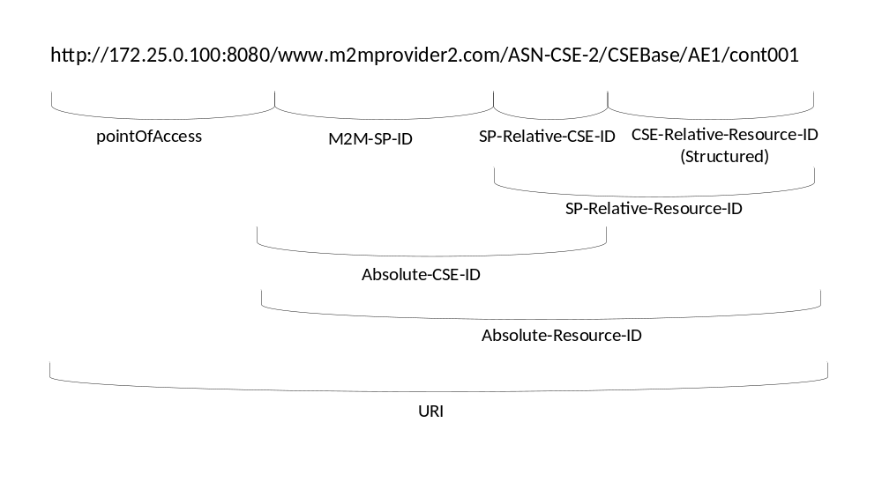
Figure 5.2-1: Example Overview of oneM2M Identifiers
When a CSE receives a service layer request and it is not the destination CSE, i.e. its CSE-ID is different from the CSE-ID specified in the “To” parameter of the request, the receiving CSE shall attempt to forward the request to one of its Registrant CSEs or its Registrar CSE. To do this, a receiving CSE will compare the CSE-ID in the request with the CSE-IDs configured within the <remoteCSE> resource it hosts for each of its Registree and Registrar CSEs. If a matching CSE-ID is found, the receiving CSE will forward the request to the corresponding CSE. If a match is not found and the receiving CSE has a Registrar CSE, it will forward the request to it. Otherwise, the receiving CSE will return an error to the originator indicating that the target cannot be found (e.g. 4004 NOT_FOUND).
An example is shown in Figure 5.2-2, where
- ASN-CSE-1 is registered to MN-CSE-1,
- MN-CSE-1 is registered to IN-CSE and
- ASN-CSE-2 registers to IN-CSE.
When an entity, e.g. ASN-CSE1 sends a request to retrieve a resource hosted by another entity, e.g. ASN-CSE2, which it does not have a registration relationhip with, it sends the request to its Registrar CSE, e.g. the MN-CSE-1. When the Registrar CSE, e.g. MN-CSE-1, receives the request, if the destination entity of the message, e.g. MN-CSE-2, does not have a registration relationship with it, it forwards the request to its Registrar CSE, e.g. IN-CSE. When the message arrives at the IN-CSE, the IN-CSE forwards the message to the ASN-CSE-2 via ASN-CSE-2’s PoA since ASN-CSE-2 is registered to IN-CSE.

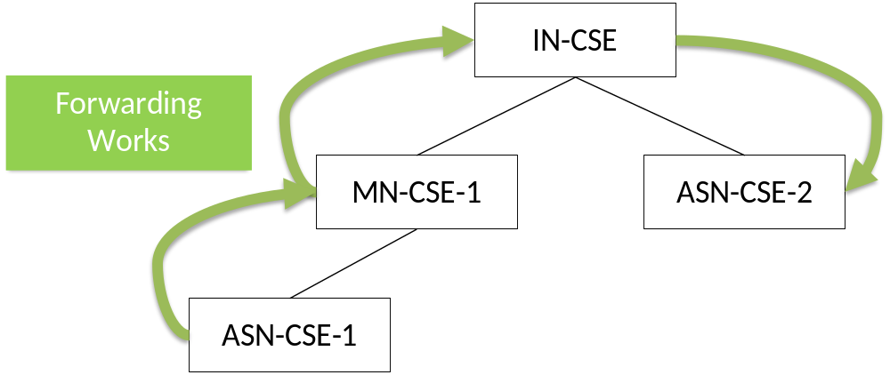
Figure 5.2-2: Service Layer Message Forwarding

5.3 Limitations
oneM2M lacks support for forwarding a request downward in the hierarchy which span across multiple CSE hops. This is because oneM2M registration only shares information between a Registrar and a Registree CSE. As a result a Registrar CSE does not have awareness of any CSEs that may be registered to any of its Registree CSEs.
An example of this limitation is shown in Figure 5.3-1, where:
- ASN-CSE-1 is registered to MN-CSE-1,
- MN-CSE-1 is registered to IN-CSE,
- MN-CSE-2 is registered to IN-CSE and
- ASN-CSE-2 is registered to MN-CSE-2.
When ASN-CSE-1 sends a message to ASN-CSE-2, ASN-CSE-1 first sends the message to MN-CSE-1 (its Registrar CSE). MN-CSE-1 forwards the request to IN-CSE (it’s Registrar CSE). However, IN-CSE does not know how to forward the message since ASN-CSE-2 is not registered to IN-CSE and MN-CSE-2 does not provide information about its registree CSEs (i.e. ASN-CSE2) to IN-CSE. Hence, when the IN-CSE attempts to find a matching CSE-ID by inspecting the <remoteCSE> resources it hosts, a match is not found.
Therefore, ASN-CSE-1 cannot send a message to ASN-CSE-2 in the currently defined oneM2M architecture without using proprietary mechanisms which causes interoperability issues.

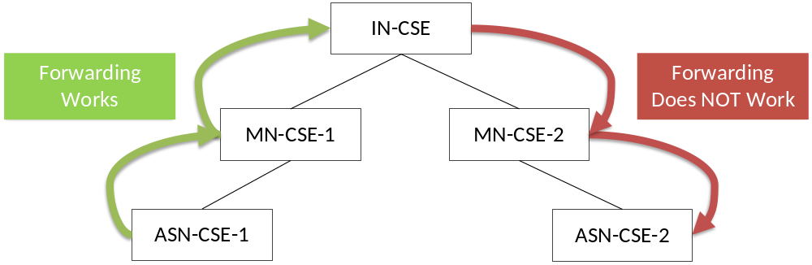 Figure 5.3-1: Limitation in oneM2M Service Layer Message Forwarding

6 Potential solutions

6.1 Forwarding using descendant CSE information

6.1.1 Description
This solution is based on a Registree CSE making its descendant CSE information available to its Registrar CSE. A descendant CSE of another CSE, e.g. CSE-1, is a CSE that is a Registree CSE of CSE-1, or registers to another CSE which is a descendant CSE of CSE-1. A CSE reports information regarding any descendant CSEs, e.g. CSE-ID, to its Registrar CSE. A new <remoteCSE> attribute named descendantCSEs is proposed in Section 6.1.1 to store descendant CSE information. An enhanced CSE registration procedure is also proposed in Section 6.1.2.2 to mange the descendantCSEs attribute.
When a CSE receives a service layer request and it is not the destination CSE, i.e. its CSE-ID is different from CSE-ID in the “To” field of the message, the CSE attempts to forward the message to another CSE. If the destination CSE is the Registrar CSE or a Registree CSE of the CSE receiving the request, the CSE forwards the request directly to the destination CSE. If the destination CSE is a descendant CSE of a Registree CSE of the CSE receiving the request, the CSE will forward the message to the Registree CSE. Otherwise, if a CSE receives a request and the destination CSE is not its Registrar CSE, not one of its Registree CSEs, nor is it a descendant CSE, then the CSE forwards the request to its registrar CSE if applicable or generates an error if not applicable.

6.1.2 New Attribute of <remoteCSE>
A new attribute named descendantCSEs is added under <remoteCSE> as shown in Figure 6.1.1-1 and specified in Table 6.1.1-1.
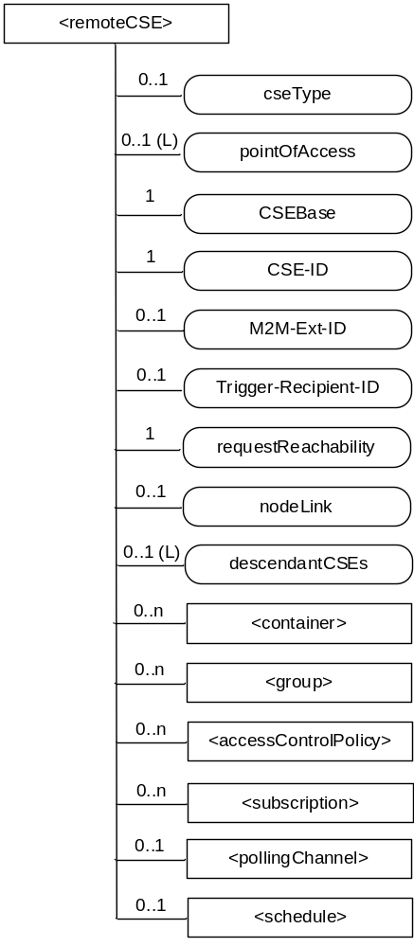
Figure 6.1.1-1 Attributes of <remoteCSE> resource
Table 6.1.1-1 New Attributes of <remoteCSE >
Attributes of <CSEBase> | Multiplicity | RW/  RO/  WO | Description
descendantCSEs | 0..1(L) | RW | This attribute contains a list of identifiers of descendant CSEs of the Registree CSE represented by this <remoteCSE> resource. A descendant CSE is a CSE that either registers to the CSE represented by this <remoteCSE>, or registers to another CSE which is a descendant CSE of this <remoteCSE>. The Registree CSE represented by this <remoteCSE> configures this attribute with a list of descendant CSEs upon creation of the <remoteCSE> resource. The Registree CSE updates this attribute whenever a new descendant CSE either registers or de-registers. The Registree CSE detects when a descendant CSE registers or de-registers by monitoring the descendantCSEs attribute(s) of its <remoteCSE> resources.

6.1.2 New Service Layer Forwarding Procedures

6.1.2.1 Procedure for a CSE to forward a Message
When a CSE receives a service layer message and it is not the destination CSE, i.e. its CSE-ID is different from CSE-ID in the “To” field, it attempts to forward the message. The Receiver CSE checks each of its <remoteCSE> resources to find whether the CSE-ID in the “To” field of the message matches the CSE-ID attribute or CSE-IDs in the descendantCSEs attribute. If the Receiver CSE finds a match in a <remoteCSE> resource, it forwards the message to the CSE that is associated with the <remoteCSE> resource. If the Receiver CSE does not find a match, it will forward the message to its Registrar CSE if applicable. If the Receiver CSE does not have a Registrar CSE, it returns an error to the originator indicating that the target cannot be found (e.g. 4004 NOT_FOUND).

6.1.2.2 Registration procedure support for service layer forwarding

6.1.2.2.1 Procedure for <remoteCSE> create
Step 1: The Originator CSE sends the CREATE Request message to the Receiver CSE with its descendant CSEs.
Step 2: The Receiver CSE performs creation of <remoteCSE> resource. If the Receiver CSE has registered to another CSE, the Receiver CSE sends an update request to its Registrar CSE to add the CSE-IDs of the Originator CSE and the Originator CSE’s descendants into the descendantCSEs attribute of the Receiver CSE’s <remoteCSE> hosted by the Registrar CSE.
Step 3: The Receiver CSE responds with a Response message.
Step 4: The Originator CSE upon receipt of the CREATE response message, creates a <remoteCSE> resource locally under its <CSEBase> resource. This resource is representing the Receiver CSE.

6.1.2.2.2 Procedure for <remoteCSE> update
Step 1: The Originator CSE sends the UPDATE Request message to the Receiver including its descendant CSEs.
Step 2: The Receiver CSE performs an update of the <remoteCSE> resource. If the descendantCSEs attribute is updated, and the Receiver CSE has registered to another CSE, the Receiver CSE sends an update request to its Registrar CSE to make the corresponding updates to the descendantCSEs attribute of the Receiver CSE’s <remoteCSE> hosted by the Registrar CSE.
Step 3: The Receiver CSE responds with a Response message.

6.1.2.2.3 Procedure for <remoteCSE> delete
Step 1: The Originator CSE sends a DELETE Request message to the Receiver.
Step 2: The Receiver CSE performs deletion of <remoteCSE> resource representing the Originator CSE. If the Receiver CSE has registered to another CSE, the Receiver CSE sends an update request to its Registrar CSE to delete the CSE-IDs of the Originator CSE and the Originator CSE’s descendants in the descendantCSEs attribute of the Receiver CSE’s <remoteCSE> resource hosted by the Registrar CSE.
Step 3: The Receiver CSE responds with a Response message.
Step 4: The Originator CSE, upon receipt of the DELETE response message, deletes the <remoteCSE> resource associated with the Receiver CSE.

7 Conclusions
In oneM2M Release 3, the present document resulted in a set of normative updates to the oneM2M TS-0001 architecture and TS-0004 protocol specifications to add support for service layer forwarding functionality. These normative updates were based on the methods described in clause 6.1 of this document.

No further work is planned for this work item and it is recommended that this work item be closed.History
This clause shall be the last one in the document and list the main phases (all additional information will be removed at the publication stage).
Publication history
V.1.1.1 | <dd Mmm yyyy> | <Milestone>

Draft history (to be removed on publication)
V.0.0.1 | 09 Oct 2016 | Initial Skeleton
V.0.2.0 | 20 Nov 2016 | Incorporated Contributions:  ARC-2016-0425-CR-Service_Layer_Forwarding_Analysis  ARC-2016-0426-CR-Service_Layer_Forwarding_Solution
V.0.3.0 | 26 Feb 2018 | Editorial Clean-up

